|  |
| --- |
| SISP X-IBTS X |
| Manual for the North Sea  International Bottom Trawl Surveys  Revision X  The International Bottom Trawl Survey Working Group |

**International Council for the Exploration of the Sea**

**Conseil International pour l’Exploration de la Mer**

H. C. Andersens Boulevard 44–46

DK-1553 Copenhagen V

Denmark

Telephone (+45) 33 38 67 00

Telefax (+45) 33 93 42 15

www.ices.dk

info@ices.dk

Recommended format for purposes of citation:

ICES. 2018. . SISP x-IBTS X. 84 pp.

For permission to reproduce material from this publication, please apply to the General Secretary.

This document is a product of an Expert Group under the auspices of the International Council for the Exploration of the Sea and does not necessarily represent the view of the Council.

ISBN 978-87-7482-112-0

ISSN 2304-6252

© 2018 International Council for the Exploration of the Sea

**Contents**

[1 Introduction 1](#_Toc420935990)

[2 IBTS survey 3](#_Toc420935991)

[2.1 Current objectives 3](#_Toc420935992)

[2.2 Survey Design 3](#_Toc420935993)

[2.3 GOV-trawl construction and rigging 6](#_Toc420935994)

[2.4 Gear quality control 14](#_Toc420935995)

[2.4.1 Before and during the Survey 14](#_Toc420935996)

[2.4.2 Quality control during the survey 16](#_Toc420935997)

[2.4.3 Quality control after a survey 17](#_Toc420935998)

[2.5 Standard fishing method 23](#_Toc420935999)

[2.6 Monitoring net geometry 24](#_Toc420936000)

[2.7 Fishing Positions 27](#_Toc420936001)

[3 Sampling of GOV-trawl catches 29](#_Toc420936002)

[3.1 Catch sorting and sampling 29](#_Toc420936003)

[3.2 Length composition 32](#_Toc420936004)

[3.3 Sampling for age, sex, and maturity 33](#_Toc420936005)

[3.4 Measurement types for invertebrates 34](#_Toc420936006)

[3.5 Measurement types for deep-water species 36](#_Toc420936007)

[3.5.1 Smoothheads and Searsids (*Alepocephalidae* and *Searsidae*) 37](#_Toc420936008)

[3.5.2 Grenadiers (*Macrouridae*) 37](#_Toc420936009)

[3.5.3 Chimaeridae (Rabbitfish) 38](#_Toc420936010)

[3.6 Collection of marine litter from trawl 38](#_Toc420936011)

[4 MIK net 39](#_Toc420936012)

[4.1 Q1 sampling 39](#_Toc420936013)

[5 Environmental data 39](#_Toc420936014)

[6 Exchange specifications for IBTS data 40](#_Toc420936015)

[7 References 45](#_Toc420936016)

[Annex 1: Current rectangle allocation between nations Error! Bookmark not defined.](#_Toc420936017)

[Annex 2: History of the IBTSWG survey and manual Error! Bookmark not defined.](#_Toc420936018)

[Annex 3: IBTS standard gear check sheet 1 Error! Bookmark not defined.](#_Toc420936019)

[Annex 4: IBTS standard gear check sheet 2 Error! Bookmark not defined.](#_Toc420936020)

[Annex 5: IBTS standard gear check sheet 3 Error! Bookmark not defined.](#_Toc420936021)

[Annex 6a: IBTS standard gear check sheet 4 – Groundgear A Error! Bookmark not defined.](#_Toc420936022)

[Annex 6b: IBTS standard gear check sheet 4 – Groundgear B Error! Bookmark not defined.](#_Toc420936023)

[Annex 7: Summary of catch processing per nation during North Sea Q1 IBTS Error! Bookmark not defined.](#_Toc420936024)

[Annex 8: Summary of catch processing per nation during North Sea Q3 IBTS Error! Bookmark not defined.](#_Toc420936025)

[Annex 9: Finfish (flatfish and roundfish) maturity key Error! Bookmark not defined.](#_Toc420936026)

[Annex 10: Four stage maturity key for skates and rays (*Rajidae*) Error! Bookmark not defined.](#_Toc420936027)

[Annex 11: Data sheet for collection of marine litter Error! Bookmark not defined.](#_Toc420936028)

[Annex 12: Haul information Error! Bookmark not defined.](#_Toc420936029)

[Annex 13: Length frequency information Error! Bookmark not defined.](#_Toc420936030)

[Annex 14: Smalk Error! Bookmark not defined.](#_Toc420936031)

[Annex 15: Area type codes: Sampling areas and standard areas for the calculation of abundance indices Error! Bookmark not defined.](#_Toc420936032)

[Annex 16: Length splits used to provide preliminary numbers-at-age Error! Bookmark not defined.](#_Toc420936033)

Annex 17:

Annex 18:

Annex 19:

# Introduction

Overview of the survey

The International Bottom Trawl Survey (IBTS) in the North Sea has been conducted in the 1st quarter of the year since the beginning of the 1960s. The survey was first aimed at juvenile herring in the central and southern North Sea, but then the objectives of the survey were broadened to also provide recruitment indices for gadoids. The survey area was extended towards the northern North Sea and the Skagerrak/Kattegat in the 1980s. From 1991 to 1996, surveys were also conducted in the 2nd, 3rd, and 4th quarters, but since 1997, only the 1st and 3rd quarter surveys remained. The current extent of the surveys can be seen in Figures A1.1 and A1.9 in Annex 1. The GOV trawl (chalut à Grande Ouverture Verticale) was introduced as the standard gear and the gear rigging and fishing method were standardized. However, some countries continued to use gears other than the GOV in the 3rd quarter IBTS until 1998.

February is the target month for the Q1 survey where Denmark, France, Germany, Netherlands, Norway, UK Scotland and Sweden participates. In Q3 August is the target month, with Denmark, Germany, Sweden, Norway, UK England and UK Scotland as participantes.

A more detailed description of the history of the North Sea IBTS surveys can be found in Annex 2.

IBTSWG coordinates fishery‐independent multi‐species bottom-trawl surveys within the ICES area. For a North Sea survey to be considered to be coordinated under IBTSWG, it must fulfil the following criteria:

1. Be carried out within the ICES areas: 27.3.a.20, 27.3.a.21, 27.4, 27.7.d;
2. An ICES assessment working group provides a brief outline of the management need/context for the survey;
3. Be an otter trawl survey, but note that there may be other working groups better placed to coordinate some bottom-trawl surveys;
4. Have appropriate survey sampling methods and protocols (including gear descriptions) that conform to the standards encouraged by the IBTSWG or that can be improved after joining the IBTSWG;
5. Aims to enhance existing IBTS surveys and improve data collection for important stocks. For example, proposed surveys for inclusion within IBTSWG will (i) overlap and extend existing survey areas using a comparable gear, or (ii) operate on more specific grounds/times of year with a gear more appropriate to the target species;
6. Store data in the DATRAS database and participate in data quality checking;
7. Nations must attend and present data at the annual meetings of IBTSWG;
8. For those surveys that do not use a gear that is the standard for IBTS surveys, confirmation must be given from assessment working groups (e.g. after a five year period) that these surveys are still providing data of high quality that are used for assessment and provision of advice.

Use of the data

Annual abundance indices by species and age group are routinely calculated in DATRAS; a description of the estimation procedure can be found at <http://www.ices.dk/marine-data/Documents/DATRAS/>, and in ICES (2013a). For herring, sprat, and saithe, weighting factors for the surface area of statistical rectangles at water depths between 10 m and 200 m are applied in the index estimation.

Data products to calculate abundance indices by swept area in addition to tow duration are available for the time series since 2004 for both Quarter 1 and 3 surveys.

# North Sea IBTS survey

## Current objectives

The North Sea surveys aim to provide ICES assessment and science groups with consistent and standardized data for examining spatial and temporal changes in (a) the distribution and relative abundance of fish and fish assemblages; and (b) of the biological parameters of commercial fish species for stock assessment purposes.

In terms of groundfish surveys coordinated by IBTS, the main objectives are:

1. To determine the distribution and relative abundance of pre‐recruits of the main commercial species with a view of deriving recruitment indices;
2. To monitor changes in the stocks of commercial fish species independently of commercial fisheries data;
3. To monitor the distribution and relative abundance of all fish species and selected invertebrates;
4. To collect data for the determination of biological parameters for selected species;
5. To collect hydrographical, environmental, and marine litter information;
6. To determine the abundance and distribution of clupeid post-larvae (Quarter 1).
7. To be used as a platform to collect ichthyoplankton data.

## Survey Design

The current stratification of the survey has always been grid-based, using ICES statistical rectangles of roughly 30 x 30 nautical miles (1 degree longitude x 0.5 degree latitude). These rectangles were convenient to use for stratification of the survey because they were already being used for fisheries management purposes. Typically, each rectangle is sampled with two hauls, by two different countries/vessels, where logistically possible (for exceptions see annex 1). Priority is given to have sampled all rectangles rather than having two samples pr rectangle.

The rectangle allocations are assigned annually during the IBTSWG and, if necessary, by the international coordinators prior to and during the survey. The international survey coordinator is responsible for the realized allocation of statistical rectangles to each country, taking into account constraints produced e.g. by weather conditions or technical failures on vessels. The coordinator supports adequate coverage during the survey by liaising with the national coordinators/survey cruise leaders.

The vessels are free to choose any position in the rectangles as long as the hauls are separated by at least 10 nautical miles where possible, except where nations take more than two tows per rectangle. Whenever possible, tows in adjacent rectangles should be separated by at least 10 miles. Countries must avoid clustering their stations between adjacent rectangles in order to reduce positive serial autocorrelation and thereby maximize survey precision.

Trawl tow locations are ultimately selected by the cruise leader for each individual country. The selection process is based on a semi-random format with each survey having a series of ‘clear’ (and in many circumstances previously visited) trawl sites. Cruise leaders are encouraged to utilize known trawl positions taken by other countries in previous years in order to increase the number of available positions within a rectangle. In the unusual event that no ‘clear’ tow exists, the cruise leader may select to undertake a ‘blind’ tow on unknown ground after checking the proposed trawl track for hazardous seabed obstructions with acoustic methods. The cruise leader will select a site that allows the cruise to maximize efficiency and secure as many trawl hauls in the ‘daylight’ period prescribed to the day in question.

**Table of current protocol for selection of GOV trawl stations by each country and quarter**

|  |  |  |
| --- | --- | --- |
| Nation | Q1 | Q3 |
| Denmark | 2, 3 | 2, 3 |
| England | NA | 4 |
| France | 2, 3 | NA |
| Germany | 2, 3 | 2, 3 |
| Netherlands | 2, 3, 5 | NA |
| Norway | 2, 3 | 2, 3 |
| Scotland | 2, 3, 5 | 2, 3, 5 |
| Sweden | 4 | 1 |

1 Depth stratified, semi-randomly

2 Proportion semi-randomized (From database of national safe tows or DATRAS or commercial fishing data)

3 Proportion opportunistic station selection (From database of national safe tows or DATRAS and from commercial data)

4 Fixed Stations

5 Proportion semi-randomized (new positions)

## GOV-trawl construction and rigging

The original construction of the 36/47 GOV-trawl is shown in Figure 2.1. It has been acknowledged by IBTSWG (ICES 2012a) that historical drift and technical creep have impacted national GOV specifications and therefore deviations from the standard manual have occurred. This technical creep has been documented, see ICES (2015a, Annex 7, WD 3). The historical drift from the standard GOV has widened to a point where it would never be possible to reverse, and it was therefore recommended that each country should maintain current standardisation.

Because the information in this manual is insufficient to fully rig the GOV trawl and in order to maintain consistency at a national level, it was recomended each nation should draft their own comprehensive user manual. This document should detail all trawl componants and rigging to provide sufficient information to fully rig their trawl gear. Furthermore, it should include a section detailing how net monitoring instrumentation, such as Scanmar or bottom contact units, are attached to the trawl.

To assist each GOV user, a set of check sheets (Annex 3 to 6b) is to be used for each trawl to maintain their standard rigged GOV. It should be noted that the check sheets provided are for guidance and should be adpted to suit each national GOV specification and rigging. All dimensions of the GOV must be checked to ensure that it is rigged correctly on the vessel. When a new net is delivered, check sheets 1 (Annex 3) and 2 (Annex 4) are to be filled in to ensure that the net is manufactured to the correct specification.

### Rigging: Kite, flyers and floats

To increase the trawl opening a kite or a flyer is fitted to the trawl. The ‘standard’ flyer is the “Exocet” kite, but other kites or flyers (e.g Voilin flyer) are acceptable as long as the resulting trawl parameters are within the acceptable bounds (see section 2.6, and rigging manual for details for each kite and flyer). Details of the "Exocet" kite and suggestions how to attach the kite to the trawl are shown in Figure 2.2. Five floats with a buoyancy of 2.9 kg each are attached to the kite.

Total buoyancy of the floats on the net is 172 kg. The floats should be spread evenly over the wings and the square.

The rigging is given in Figure 2.3. On board the vessel, when attaching the trawl to the bridles and doors, use check sheet 3 (Annex 5).

### Net geometry - sweeps

The most important consideration is that the **net geometry is within the acceptable limits** for the depth of water (see Section 2.6 on monitoring net geometry and theoretical headline height and door spread limits for deployment depth). Because the acceptable limites were not achieved by some nations, particularly when using the long sweeps at deeper stations, several countries stopped changing sweep lengths during the Q1 surveys. Current advice is for all nations to maintain their current rigging, therefore Norway and Sweden will continue to vary sweep length with bottom depth.

Deviations from the standard trawl specification are further detailed in Annex 2, Table A2.4.

### Groundgear

The standard groundrope with rubber discs (groundgear ‘A’) as shown in Figure 2.4 is used throughout the survey area. However, since 1985, Scotland have used groundgear ‘B’ on all stations north of 57° 30’ North because of the rough bottom (Figure 2.5). Use check sheet (Annexes 6a and 6b) to ensure the groundgear is to specification.

Extra weights in the groundrope are 70 kg in the square, 35 kg in each quarter and 35 kg in each forward wing-end. These weights should be evenly spread over the appropriate length of groundrope and this can be achieved by wrapping chain externally around the groundrope, using a thicker centre chain, or by interspersing the groundrope rubber discs with steel discs of the same diameter. Approximate weight in air is given for each section of the groundgear.

Proper contact of the groundgear should be monitored by use of acoustic devices, in addition to checking the wear on chains, and presence of benthic organisms and flatfish in the catch. The contact of the groundgear with the bottom can be greatly influenced by changing the length of the adjustment chain between the lower leg and the bumper bobbin. The normal length of this chain is 2 metres but on rough ground it can be shortened to 1.7 metres; if the gear is fishing too light it can be lengthened to 2.2 metres. Shortening the chain means the net sits lighter upon the bottom, but care must be taken to maintain proper bottom contact throughout the tow duration.

### Trawl net

For a proper performance of the net, it is essential that the four upper bridles are of identical length, and regular checks must be made to ensure this. A total check of the trawl must be carried out prior to the survey. Annex 7 contains the net plans and gear components tables for all countries, as supplied in 2015 (ICES 2015a, Annex 9).

When checking the GOV mesh sizes, either during construction or on rigging the net, either an Omega net gauge or another standard net gauge should be used. See figure below for how to measure the mesh opening vs. the stretched mesh.

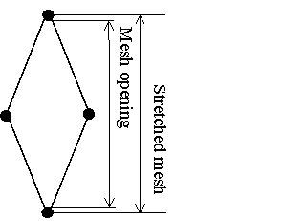

During measuring, a 5% tolerance is allowed. When using the Omega Gauge, please follow the manufacturers’ instructions for correct use, as overstretching could be an issue. The net can be measured either wet or dry. This is a summary of the information taken from the working document presented at IBTSWG in 2008 (ICES 2008, Annex 5, WD1).

The lining of the codend should consist of 400 stretched meshes of 20 mm each, giving a total length of 8 m. The total circumference of the lining should be 600 meshes.

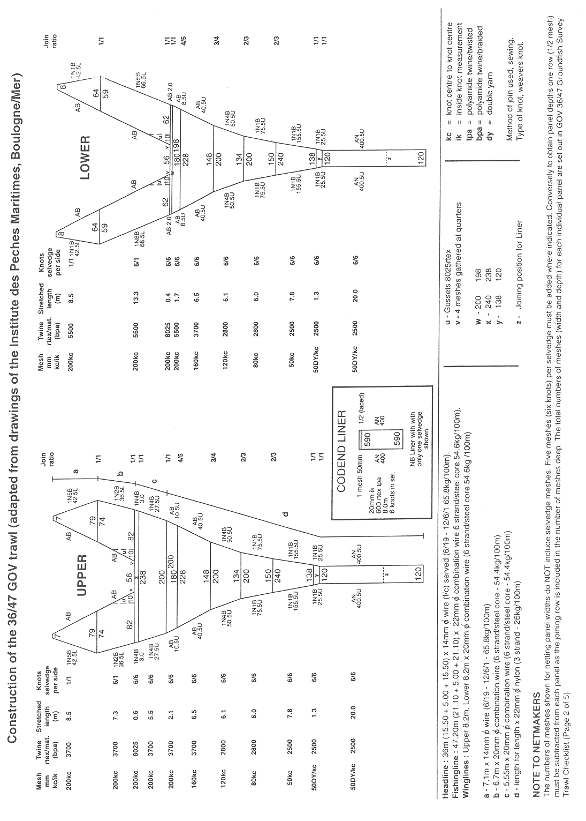

Figure 2.1. Construction of the 36/47 GOV Trawl.

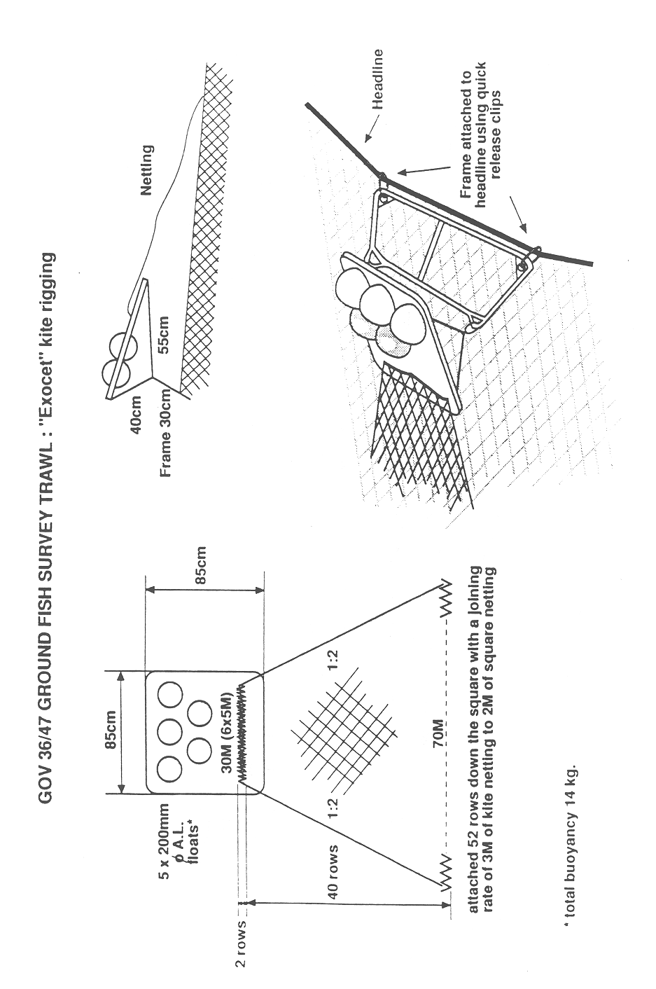

Figure 2.2. "Exocet" Kite for the 36/47 GOV Trawl.

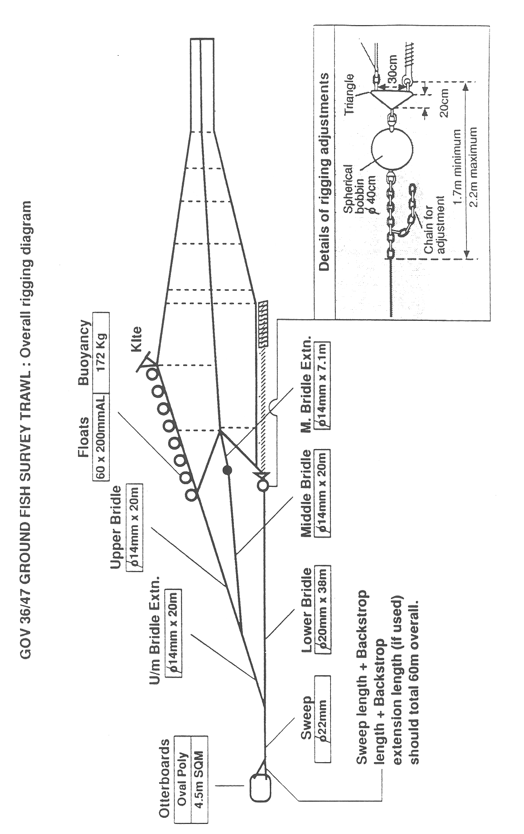

Figure 2.3. Rigging of the 36/47 GOV Trawl.

GOV36_47

Figure 2.4. Standard groundrope for the 36/47 GOV trawl groundgear ‘A’.

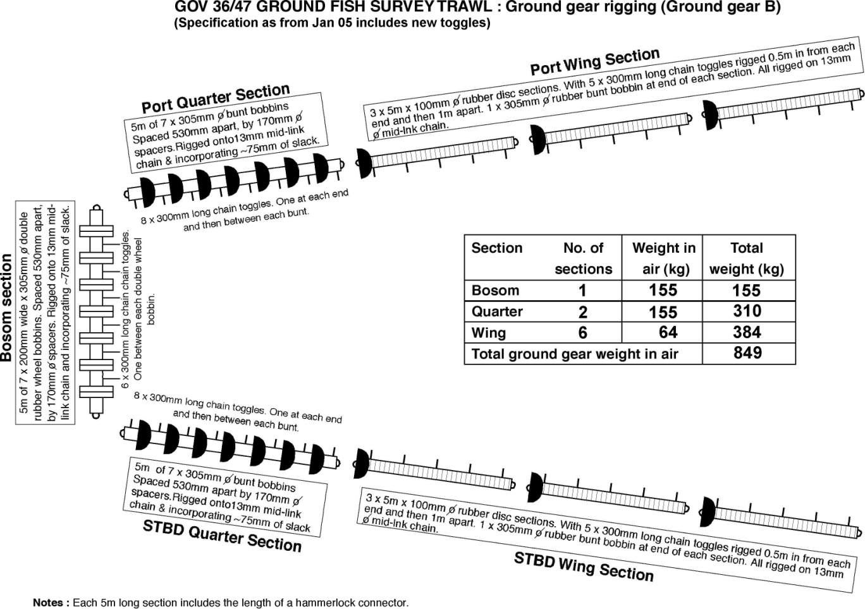

Figure 2.5. Groundrope for the 36/47 GOV trawl groundgear ‘B’.

## Gear quality control

### Before and during the Survey

The flow diagram can be used to describe the procedure for the preparation of the GOV trawl prior to the survey and each haul (Figure 2.6).

The table below presents a short description for each country of the procedure for the preparation of the gear before and during the survey.

| Procedure for the preparation of the gear before and during the survey | |
| --- | --- |
| Denmark | Before the survey: Primary and spare trawls are visually inspected when taken onboard.  During the survey: Nets are checked and measured according the check sheets 1-3 if the correct door spread and vertical net opening cannot be achieved or after damages by the fishing master. The control sheets are given to scientist in charge. |
| England | Before the survey: The primary net and a spare net are pulled out at the net store. The net manager along with the primary and secondary scientists in charge check the net using the specification sheets in Annex 3 to 6b of this manual  During the survey: The flow diagram in Figure 2.6 is followed. The damages and repairs are reported on the specification sheet, which is given to the scientist in charge at the end of the survey. |
| France | Before the survey: The net, which has its own specification sheet, is prepared by the fishing master and checked in presence of the scientist in charge.  During the survey, the procedure is followed according to the flow diagram. The damages and repairs are reported on the specification sheet, which is given to the scientist in charge at the end of the survey. A copy is sent to the technologists team. |
| Germany | Before the survey: The primary net and spare nets are transported aboard from the net store and prepared by the ship’s crew (netmaker) according to the IBTS manual. The chief scientist does not conduct a formal control, but a visual inspection of the rigged net on deck.  During the survey, small net damages are repaired directly after each haul; in the case of larger damages, the replacement net is rigged. No documentation is made of net damages, but the haul is marked invalid if the captain / chief scientist assume that the haul has been affected by the damage. |
| The Netherlands | Before the survey: The primary net and a spare net are checked by the IMARES gear technician together with the crew on board following the specification sheets 3 and 4 of this manual.  During the survey: The crew rigs, controls, and repairs the net if necessary. |
| Norway | Norway revised its procedures in 2015. Before the survey, primary and spare nets (4 in total) are pulled out at the net store. Primary nets are visually inspected by the trawl master and a gear technician, if present, on the vessel. The survey coordinator and gear technician ensure the trawl master has the necessary information to rig the gear properly. Gear calibration trials are performed prior to starting the survey to ensure all gear, including sensors, are working properly.  During the survey: The crew rigs, controls, and repairs the net if necessary. All repairs are noted in gear specification sheets and added to the ‘trawl history’ binder that follows each set of gear. If a net is excessively damaged, a replacement is rigged and calibrated before use. The trawl history binder is delivered to the gear store with the nets at the end of the survey; nets are then inspected and repaired, if needed. The haul is marked invalid if the captain/science survey leader deem that the catch has been affected by the damage. |
| Scotland | On each IBTS survey, four GOV trawls are carried aboard Scotia and rotated each cruise so they all get similar soak time. Any trawls used during the preceding survey are fully checked over by staff in the Marine Laboratory Netstore and given a full overhaul. Prior to each survey, all wires and groundgear sections are inspected and measured and if found defective replaced or re-rigged. Prior to the start of each survey, the initial rigging aboard the vessel is undertaken by the crew in the presence of either a gear technologist, scientist in charge (SIC), or nominated competent deputy. During the rigging, a member of scientific staff ensures the gear conforms to the standard trawl/gear rigging plan and acts as a point of contact between the vessel and net store to resolve any queries or problems. Gear technologists at the Laboratory have drafted a rigging manual that details how every component connects together to fully rig the GOV (from trawl door to codline) for Scottish surveys. This manual is more detailed than the IBTS manual and is intended to act as an aid for RV vessel crews and scientists to ensure consistency on every survey.  As standard practice on every survey, one member of the scientific staff is allocated responsibility to act as deck person. This role includes observing shooting and hauling of the gear, along with operating the SCANMAR and bottom contact instrumentation and relaying any issues to the SIC.  During the survey, the procedures as detailed in the flow diagram (2.6) are followed. An electronic haul-by-haul record (Net check form) is kept by the deck person for each trawl used and this details any damage sustained and repairs or replacements made to the fishing gear. A copy of this file is given to the SIC at the end of the cruise. |
| Sweden | Before the survey: Currently Sweden carry two GOV-trawls on board. Both trawls will be checked and measured by the net maker on a yearly basis, if possible with the cruise leader present.  The flow diagram in Figure 2.6 is followed, except that the fishing master and with onboard crew rig the trawl without staff from the Institute. |



Figure 2.6. IBTS GOV preparation flow diagram.

### Quality control during the survey

The GOV trawls are generally used for several surveys during the year. They must be regularly checked by the fishing crew with scientists and/or gear technologists. Each gear must have a specification sheet where all modifications or damage occurred during a survey are registered.

### Quality control after a survey

Each country has its own protocol for quality control of the net. The procedure implemented is described in the table below.

|  |  |
| --- | --- |
| Frequency of the Quality Control and brief description of the procedure after the survey | |
| Denmark | At the end of the survey: If necessary, repairs are specified by the fishing master and discussed with the scientist in charge. |
| England | Before the next survey, the main trawl and the spare trawl are completely checked by the net store personnel under the responsibility of the Scientist in Charge. Results are recorded and kept on file by the net store manager and the Scientist in Charge of that survey. Trawls are identified by a specific number assigned when originally received by the net store after initial purchase. |
| France | Since 2010, a new quality control procedure was implemented at Ifremer. Once a year, all trawls are completely checked by the crew under the responsibility of the gear technologists. A detailed protocol describes all controls that must be done. Results are sent to the cruise leaders and uploaded on the Ifremer Intranet site. Trawls are identified by a specific number (acquisition year and order number) |
| Germany | During and after each survey, the netmaker/ captain inform the chief scientist if net material needs to be purchased for replacement. |
| The Netherlands | At the end of the survey: If necessary, repairs are specified by the fishing master and discussed with the scientist in charge. |
| Norway | Norway revised its procedures in 2014. The nets are checked by the net store personnel and a gear technician after the survey. Results are recorded and kept on file – electronic and in the ‘trawl history’ binder that follows each set of gear; gears are numbered for identification. Any specific problems that need resolution are brought up to the trawl forum for discussion and solving. |
| Scotland | Prior to each survey, any used trawl gear is thoroughly inspected and, where required, repaired or replaced by Marine Lab net store personnel supervised by the store manager. Results are recorded and kept on file by the net sore manager. All trawls have a unique number identifier and all wires are tagged with their details (length and diameter). All newly purchased trawl gear is inspected by the net store manager prior to being brought into stock.  Revised quality control protocols were introduced during 2003 and these firmed up procedures with regard to rigging and operation of all survey gears during Marine Laboratory cruises. As mentioned in the previous section, a rigging manual specific to the Scottish GOV has been drafted and acts as a master specification when RV crew are rigging and operating the fishing gear. |
| Sweden | The fishing master and the cruise leader compile a post-cruise trawl status list for the trawls that have been used to make sure that faulty or worn parts of the netting and the rig are replaced prior to next survey.  The repairs are documented. |

#### Quality control steps

Checking procedures have to follow several steps and each piece of the net has to be verified, as well as the rigging, the doors, the salvages, panel frames, and the groundrope. Sheets presented from Annex 3 to Annex 6b are to be used as a guide to check the trawl.

The trawl must be stretched out on the ground. It is recommended that all pieces are measured by the same person. Each piece is defined by its length, thread strength, shape, meshing, and identification number indicated on a reference plan.

Different controls made by each country are described in the following tables.

|  |  |
| --- | --- |
|  | Net panels |
| Denmark | As specified in the IBTS manual. |
| England | The size of each panel is calculated according to the mesh number. Selvedge meshes are not included. To be valid, the mesh number must be identical as the values described in the original net diagrams (Section 2.3). The net is measured dry and not damp. Meshing control consists in measuring 20 meshes consecutively. A bronze mesh gauge is used to measure the height of the meshes from front to back. An average is taken from the 20 meshes recorded and the tolerance between nominal value and effective value is ±5%. |
| France | The size of each panel is calculated according to the mesh number. Selvedge meshes are not included. To be valid, the mesh number must be identical as the nominal values. Otherwise, a second numbering has to be done. The tolerance between nominal value and effective value is :  ± 1 mesh for the base  ± 0.5 mesh for the height, for each piece except the codend.  ± 2 meshes for the GOV 36/47 codend.  ± 10 meshes for the double codend.  The thread strength, is checked comparing the thread of each piece and standard commercial samples  Each part of the net must be dampened regularly (uniformly) before being measured. Meshing control consists in measuring 20 meshes consecutively. The zero of the ruler placed on the upper mesh knot and the measurement is read below the opposite knot.  Piece meshing is calculated working out the average of the consecutive 20 meshes. The millimetre is the unit used to measure the mesh and the tolerance between nominal value and effective value is ±5%. |
| Germany | No formal procedure has been specified in writing; control in responsibility of netmaker. |
| The Netherlands | As specified in the NS-IBTS manual. |
| Norway | As specified in NS-IBTS manual as of 2014. If a new net is needed, the gear store arranges for its purchase from the Norwegian net maker, ensuring conformity to the standard net plan. |
| Scotland | All netting used to repair or renew GOV trawls is purchased by the Marine Laboratory net store from an outside supplier. It is specified from the manufacturer as full mesh size and subsequently measured (meshes per 1m) on delivery by the net store manager to ensure conformity with the standard net plan. After each cruise, the netting panels of every used trawl are inspected and if found to be stretched or distorted, replaced. No ± mesh tolerances are used as every panel must conform to the number of meshes and length described in the standard net diagrams. |
| Sweden | When checking the trawl, the net store (with cruise leader present) follow the gear checking sheets supplied in Annex 3 in the IBTS manual.  If no panels have been altered the number of meshes aren't counted. |

|  |  |
| --- | --- |
|  | Salvages and panel frames |
| Denmark | As specified in the NS-IBTS manual |
| England | Salvages and panel frames are attached along parts of the net. Each is stretched and measured with a tape measure from eye to eye. The unit is the centimetre and tolerance between nominal value and effective value is ±5cm. On the same part of the trawl, the port side and the starboard must be equal and difference does not exceed ± 5 cm. |
| France | Lines are attached along parts of the net. Each of them is stretched and measured with a decameter from eye to eye. The unit is the centimetre and tolerance between nominal value and effective value is ±5cm. The diameter is controlled with a calliper rule and tolerance between nominal value and effective value is ±5mm. On the same part of the trawl, the port side and the startboard must be equal and difference does not exceed ± 5 cm. |
| Germany | See above |
| The Netherlands | As specified in the NS-IBTS manual |
| Norway | As specified in the NS-IBTS manual |
| Scotland | Selvedge and panel framelines are attached along parts of the trawl. All are measured to the exact value specified in the standard plan. After a survey, each used trawl is returned to the laboratory net store, where all lengths and diameters are checked and, if different from the standard plan, replaced. Particular attention is made to checks along the nylon (PA) selvedge rope sections as these shrink and are replaced regularly. When selvedge ropes are replaced on one side of the gear, the opposite side is automatically replaced. |
| Sweden | When checking the trawl, the net store (with cruise leader present) follow the gear checking sheets supplied in Annex 3 in the IBTS manual. |

|  |  |
| --- | --- |
|  | The groundrope |
| Denmark | Once measured, not re-measured unless damaged. |
| England | The groundrope is stretched on the floor and its different parts measured with a tape measure. The unit is the centimetre and the tolerance does not exceed ± 5cm. |
| France | The groundrope is stretched on the floor and its different parts measured with a decameter. The unit is the centimetre and the tolerance does not exceed ± 5cm. The weight of the groundrope could be only estimated. Its load must be well distributed on the square and equal between the port side and the starboard wings. |
| Germany | See above |
| The Netherlands | Once measured not re-measured unless damaged. |
| Norway | Once measured not re-measured unless damaged. |
| Scotland | Two sets of each groundrope (A and B) are available for each survey They are checked and measured twice per year, the unit is the centimetre and the tolerance does not exceed + 3cm. |
| Sweden | When checking the trawl, the net store (with cruise leader present) follow the gear checking sheets supplied in Annex 3 in the IBTS manual. |

|  |  |
| --- | --- |
|  | The rigging |
| Denmark | Once measured, not re-measured unless damaged. |
| England | Each part of the rigging (bridles and sweeps) are stretched on the floor. They are measured with a tape measure in the same procedure as the frames. The unit is the centimetre and the tolerance value is ± 0.5%.  The port side and the starboard symmetry must be checked and difference does not exceed ± 2 cm. |
| France | Each part is defined by a specific number (example in table below) which will be stamped on each coupler’s cables.  Each part of the rigging is stretched on the floor. They are measured with a decameter in the same procedure as the lines. The unit is the centimetre and the tolerance value is ± 0.5%.  The port side and the starboard symmetry must be checked and difference does not exceed ± 2 cm.  The diameter is controlled with a calliper rule and tolerance between nominal value and effective value is ±2mm |
| Germany | See above |
| The Netherlands | Once measured, not re-measured unless damaged. |
| Norway | Once measured, not re-measured unless damaged. |
| Scotland | Each part of the rigging (bridles and sweeps) are checked and inspected by the net store manager prior to a survey. They are measured with a tape measure in the same procedure as the frames. The unit is the centimetre and the tolerance value is + 0.3% or, if less than the required length, it’s condemned and removed from service. All acceptable components are then tagged and ready for dispatch down to vessel for rigging. When rigging the gear prior to starting the survey, the scientific desk person in conjunction with the Fishing Master ensures the gear is rigged to the correct specification. |
| Sweden | Each part of the rigging (bridles and sweeps) is measured with a tape measure and the port and starboard symmetry checked in accordance with the gear check sheets. If needed, they are adjusted by our trawl net store. |

|  |  |
| --- | --- |
|  | The doors |
| Denmark | Once weighed, no further measurements taken |
| England | Each pair of door is identified by the same number. The doors are only weighed when repaired. A scale is used to weigh the doors (in kilo). Tolerance interval between the nominal value and the effective value is ± 5% for each door.  The length and the height of the doors, as well as the back-strops, are measured. The unit is the centimetre and the tolerance value is 5 cm. Differences between the port side and the starboard back-strops does not exceed 5cm. |
| France | Each pair of door is identified by the same number. At the first time, the size and the weight are checked without rigging. For further controls, it will be possible to control the weight with the rigging.  A scale is used to weigh the doors (in kilo). Tolerance interval between the nominal value and the effective value is ± 5% for each door.  The length and the height of the doors as well as the back-strops are measured. The unit is the centimetre and the tolerance value is 5 cm. Differences between the port side and the starboard back-strops does not exceed 5cm. The weight between the 2 doors does not exceed 2% |
| Germany | No regular inspection of doors. |
| The Netherlands | Once weighed, no further measurements taken |
| Norway | Once weighed, no further measurements taken. |
| Scotland | Each set of polyvalent doors are identified by a unique number with the port door and starboard doors being given an odd and even value respectively. The doors are only weighed when new or repaired, but unless otherwise damaged, the policy is to change out the keels every 5 years. Tolerance interval between the nominal value and the effective value is ± 5% for each door. The Marine Lab has 2 sets of polyvalent doors and each set are always fished as a pair and never mixed. If a door is damaged or lost, then it is replaced using the unique Morgere identifier, which relates back to original production in the factory.  The length and the height of the doors, as well as the back-strops, are measured. The unit is the centimetre and the tolerance value is 3 cm. Differences between the port side and the starboard back-strops does not exceed 3 cm. |
| Sweden | The doors are checked for damages and measured/weighed if repairs are done. |

**Summary of quality controls used for GOV.**

|  |  |  |  |  |  |  |  |
| --- | --- | --- | --- | --- | --- | --- | --- |
|  | Control  Frequency | Net  Tolerance % | | Rigging  Tolerance % | | | |
| Size & length | Meshes size | Salvages and frames | Groundrope | Rigging | Doors |
| Denmark | As required | As described in check sheets | As described in check sheets | As described in check sheets | As described in check sheets | As described in check sheets | As described in check sheets |
| England | Annually | ± 5%  (length) | ± 2 meshes | ± 5cm (length)  difference port side / starboard ± 5 cm | ± 5cm (length) | ± 5% (length) | ± 5% (each door)  ± 2% (between the 2 doors) |
| Scotland | Prior to every survey | 0% | Must conform to length and count of meshes in standard net plan. | Length must match standard net plan otherwise replaced. | + 3cm (length) | +0.3% (length) | ± 5% (each door) |
| Netherlands | As required | As described in check sheets | As described in check sheets | As described in check sheets | As described in check sheets | As described in check sheets | As described in check sheets |
| Germany | Prior to every survey | Expert judgement of netmaker | Expert judgement of netmaker | Expert judgement of netmaker | Expert judgement of netmaker | Expert judgement of netmaker | Expert judgement of netmaker |
| Norway | Prior to every survey | As described in check sheets | As described in check sheets | As described in check sheets | As described in check sheets | As described in check sheets | As described in check sheets |
| Sweden | As required (but at least once a year) | As described in check sheets | As described in check sheets | As described in check sheets | As described in check sheets | As described in check sheets | As described in check sheets |
| France | Annually  (since 2010) | ± 5%  (length) | Base : ± 1 mesh  Height : ± 1 mesh  Codend : ± 2 meshes  Double codend : ± 10 meshes | ± 5cm (length)  difference port side / starboard ± 5 cm | ± 5cm (length) | ± 5% (length)  ±2mm. (diameter) | ± 5% (each door)  ± 2% (between the 2 doors) |

## Standard fishing method

### Calibration at start of the survey

It is suggested that all nations undertaking standardized surveys allocate some of the survey time to carrying out additional hauls at the start of the survey with the specific aim of ensuring that all standard elements of the groundfish survey are working correctly (i.e., calibration of trawl and sensors). This includes:

* Gear deployment: is the gear rigged correctly and being deployed and retrieved appropriately by the crew? Is all deck machinery functioning?
* Ground contact: do the groundgear, doors, and sensors indicate that the net is on the bottom and fishing correctly?
* Trawl sensors and CTDs: are all electronic equipment functioning correctly and collecting meaningful data?
* Catch processing: are all elements of catch processing and data inputting functioning?

Though there are good reasons for having these additional hauls in the main survey area. For practical reasons, they should be undertaken near the port of departure. This would then allow additional staff (including a gear technologist) to be present to fully check the gear and electronics, and would also save time in case something requires further attention.

### Trawling speed

Standard fishing speed is 4 knots measured as vessel speed over the ground. The recommended speed is set as a target and actual (ground) speed and distance towed must be monitored and reported. With tide and weather effecting the average speed of a vessel, as a guide, the minimum speed should not go below 3.5 knots and the maximum should not exceed 4.5 knots, with the average for the entire tow being as close to 4 knots as possible. It is also recommended that, if possible, the speed of the trawl through the water should be monitored by a speed sensor mounted on the net and reported.

### Fishing depth

The maximum fishing depth for standard stations in the entire survey area is 250 m.

### Tow duration

A standard tow is fished for 30 minutes. Start time is defined as the moment when the gear parameters are stabilizing (e.g., vertical net opening, speed over ground, wingspread, doorspread), as monitored by sensors. Stop time is defined as the start of the winches hauling the net back in and at this time, vessels should reduce speed considerably. It may be acceptable to fish for less than this i.e. haul early for safety reasons or in the case of very large catches, however, any tow under 15 minutes is considered invalid. Invalid are not included in index calculations and therefore a second valid station must be attempted in that rectangle.

### Vertical opening, wingspread, doorspread

All countries must use electronic equipment to monitor net geometry. Refer to the sensor manual for the correct method for attaching the units to the gear. Vertical net opening (headline height over bottom), wingspread, and doorspread are to be monitored at as high a rate as possible (at least 30-second intervals; 1-second intervals are recommended) and, after appropriate filtering for invalid values, the mean value is reported. It is highly recommended that all gear parameter files are recorded and archived. Summarized trawl monitoring data are to be sent to DATRAS with the standard upload from institutes databases.

### Trawling during daylight only

In the morning, the net cannot be shot (i.e. touching the ground) earlier than 15 minutes before sunrise. At the end of the day, the net must be hauled (having left the ground) within 15 minutes after the time of sunset. It is recommended to use an electronic application or lookup table to determine the times of sunrise and sunset (compare Annex 9).

## Monitoring net geometry

To ensure a valid tow, gear stability is crucial. **Throughout the tow, it is imperative that net geometry is measured, and that data are collected at an appropriate resolution.** If needed, the warp length to depth ratio should be adjusted to remain within accepted limits of net geometry; this ratio can vary between vessels, as an example Scotland uses a ratio of 3:1 plus 30 m for warp. Constant monitoring of the gear is necessary to build up a base-line of gear performance for the national coordinators/cruise leaders, making it easier to spot abnormal gear behaviour while on a survey. If the readings remain outside the recommended values for an unacceptable period of time, it could mean that the gear has become fouled or damaged and should be hauled. Each country should aim to keep their gear performance within the bounds of what is considered normal for their gear (Annex 8).

Figure 2.7 shows the recommended theoretical ranges of the headline height and door spread of the GOV relating to the depth of water. This should be used as a guide to ensure optimum gear performance. Table 2.1 details the formula and parameters used to create the bounds shown in Figure 2.7, allowing the user to determine how their gear operates in relation to the recommended range. Currently, there is no theoretical relationship for wingspread; however, see Annex 8.



Figure 2.7. General guidance with average recommended upper and lower limits of vertical net opening and door spread in relation to depth. For the specified recommendations for each of the gears used, please refer to Annex 9.

Table 2.1. Definition of recommended upper and lower limits of vertical net opening and door spread in relation to depth (y = a + b \* exp(-c \* z), where y is net opening or door spread and z is depth in meters). National-specific definitions are in Annex 8.

|  |  |  |  |  |
| --- | --- | --- | --- | --- |
|  | Net opening limits | | Door spread limits | |
| Coefficient | upper | lower | upper | lower |
| a | 3.7461 | 4.9088 | 84.3842 | 103.9178 |
| b | 1.7689 | 1.7727 | -39.4195 | -39.6521 |
| c | 0.0140 | 0.0142 | 0.0140 | 0.0139 |

The following flow diagram should be used to help in the process of using net performance sensors and units during a GOV haul (Figure 2.8).



Figure 2.8. IBTS flow diagram for use of data from net performance sensors.

## Trawl stations

Most statistical rectangles contain a number of possible tows that are deemed to be free of obstruction. From these the survey coordinator will draw a random set of trawl locations to be used in the specific surveys. This ensures a semi-random design of the survey allowing for estimating the statistical uncertainty of the catches. For practical and historic reasons some countries have not implemented this semi-random station selection, but continued with the historical fixed station survey design. In some rectangles, sampling may be further stratified due to significant changes in seabed depth, which may, in turn, cause variations in the fish population. If not fishing at the predefined stations, vessels are free to choose any positions in the rectangles that they are surveying if hauls are sufficiently far apart from each other. In rectangles or strata that are to be sampled more than once by the same vessel, it is recommended that valid hauls are separated by at least one day (24-hours) or by at least 10 miles. Tows conducted by the same vessel in adjacent rectangles must also be separated by at least 10 miles, except where one country takes more than 2 tows per rectangles. Exceptions can also be made, e.g. in rectangles with little surveyable area, stations may be less than 10 nm apart. Countries must avoid clustering tow positions between adjacent rectangles in order to reduce positive serial autocorrelation and thereby maximize survey precision. Survey partners exchange information on available clear tows between vessels in order to increase the variance in fishing positions used. Fish shoals located by sonar or echosounder must not influence fishing locations.

# Sampling of GOV-trawl catches

## Catch sorting and sampling

The catch from all valid hauls must be fully sorted if practically possible. Fish and shellfish species are identified to the lowest taxonomic level possible. For larger catches, a selection of species/size categories of species may be identified as being sufficiently abundant that they can be subsampled appropriately.

Only if it is practically impossible to identify to species level may some be grouped by genus or larger taxonomic group (e.g. *Pomatoschistus*, Ammodytidae). Table 3.1 lists the shellfish and cephalopods that must be sorted, measured, and included in the data submission to DATRAS.

### Additional collection of invertebrates (benthos)

Although standardized data collection for fish is well established in IBTS protocols (see below), there is no standardized approach to the submission of data on the catches and size distribution of other invertebrate species (those not in Table 3.1). No agreed protocols for the collection and submission of data exist because the levels of taxonomic expertise on board vessels can be variable. The GOV is not an effective gear for catching benthos for quantitative sampling, but it can be used for some crude distribution information, as long as the limitations of the gear are taken into consideration, e.g., the type and rigging of the groundgear, the size of the net meshes. These data may be collected as presence/absence or weights/numbers. It is at the discretion of the institute collecting the data to decide what means is most appropriate. Hence, national laboratories collecting information on benthos may continue to do so.

Table 3.1. Shellfish and cephalopods to be recorded and/or measured during surveys.

| AphiaID | Common name | Scientific name | Recording | Measurement | Unit |
| --- | --- | --- | --- | --- | --- |
| Crustaceans | | | | | |
| 107275 | Golden crab | *Cancer bellanius* | Male/Female | Carapace width | mm below |
| 107276 | Edible crab | *Cancer pagurus* | Male/Female | Carapace width | mm below |
| 107369 | Deep-water red crab | *Chaceon affinis* | Male/Female | Carapace width | mm below |
| 107253 | European lobster | *Homarus gammarus* | Male/Female | Carapace length | mm below |
| 107703 | Crawfish/spiny lobster | *Palinurus elephas* | Male/Female | Carapace length | mm below |
| 107704 | Pink spiny lobster | *Palinurus mauritanicus* | Male/Female | Carapace length | mm below |
| 107350 | Spider crab | *Maja (Maia) squinado* | Male/Female | Carapace length | mm below |
| 107254 | Norway lobster | *Nephrops norvegicus* | Male/Female | Carapace length | mm below |
| 107205 | Stone crab | *Lithodes maja* | Male/Female | Carapace length | mm below |
| Bivalves | | | | | |
| 140712 | Edible scallop | *Pecten maximus* | Sexes combined | – | – |
| Cephalopods | | | | | |
| 141444 | Cuttlefish | *Sepia officinalis* | Sexes combined | Mantle length | cm below |
| 141443 | Cuttlefish | *Sepia elegans* | Sexes combined | Mantle length | cm below |
| 141445 | Cuttlefish | *Sepia orbignyana* | Sexes combined | Mantle length | cm below |
| – | Squids | *Teuthoidea*(\*) | Sexes combined | Mantle length | cm below |
| 416668 | Squids | *Loligo forbesii* | Sexes combined | Mantle length | cm below |
| 140271 | Squids | *Loligo vulgaris* | Sexes combined | Mantle length | cm below |
| 153131 | Squids | *Alloteuthis subulata* | Sexes combined | Mantle length | cm below |
| 140625 | Squids | *Todaropsis eblanae* | Sexes combined | Mantle length | cm below |
| 140624 | Squids | *Todarodes sagittatus* | Sexes combined | Mantle length | cm below |
| 140621 | Squids | *Illex coindetii* | Sexes combined | Mantle length | cm below |
| 140600 | Lesser octopus | *Eledone cirrhosa* | Sexes combined | – | – |
| 140605 | Octopus | *Octopus vulgaris* | Sexes combined | – | – |
| – | Bobtail squids etc. (\*) | *Sepiola/Rossia/Sepietta* | Sexes combined | – | – |
| 141454 | Bobtail squids | *Sepiola atlantica* | Sexes combined |  |  |
| 141452 | Bobtail squids | *Sepietta oweniana* | Sexes combined |  |  |
| 141449 | Bobtail squids | *Rossia macrosoma* | Sexes combined |  |  |

(\*) Identification to species level where possible, though juveniles may need to be aggregated.

The following flow diagram can be used as a guide to dealing with the catch (Figure 3.1).



Figure 3.1. IBTS catch processing flow diagram.

## Length composition

Length distributions are recorded for **all fish species caught**. Length is defined as total length, measured from tip of snout to tip of caudal fin, for all fish species other than those described in Section 3.5. Length is measured to 0.1cm below for shellfish, to 0.5 cm below for herring, sprat, and boarfish and to 1 cm below for all other species. When measuring shellfish species, consult Figures 3.2 to 3.5 to ensure the correct carapace measurement is taken. When measuring cephalopods, use dorsal mantle length (see Figure 3.6).

Elasmobranchs and crustaceans are to be measured and weighed by sex.

### Sorting and sub-sampling according to length groups

After sorting the catch into species or species/sex, a length distribution for each catch category that accurately represents the length distribution of the catch must be obtained. As a general guide, for catches with more than 75 individual, a representative subsample is selected of at least 75 fish (may be less for limited length ranges and more for extensive length ranges). For large catches above 1000 individuals, the sample size should be increased to 150 fish.

If representative subsample cannot be selected, when there are two or more distinct length groups (i.e. small and large fish with none inbetween) in the catch with a clear division between them, splitting in two size categories is necessary. See the following examples:

1. A catch of 999 fish from 18–26 cm and one fish at 40 cm. A single subsample of 100 fish, when raised, will give either 10 or 0 fish at 40 cm. The correct approach is to remove the one large fish and measure it separately, treating that sample as category 1, and take a subsample from the remaining 999 fish (category 2)..
2. A catch of 994 fish in the length range 18–26 cm and 3 fish from 10–12 cm and 3 fish from 38–40 cm. A single raised subsample of 100 fish could give anything between 0 and 6 fish in the length ranges 10–12 cm and 38–40 cm. The correct approach is to remove the small and large fish and measure them as category 1, and then take a subsample from the remaining 994 fish (category 2).

## Sampling for age, sex, and maturity

Otolith samples are to be collected from each trawl station by all nations. Both otoliths from each fish are to be collected. Fish with deformities should not be sampled.

Nations are to collect 1 otolith per 1 cm length group (0.5 cm length group for herring and sprat) from each trawl haul, see specifications in table below:

|  |  |
| --- | --- |
| Species | Minimum number of otoliths to be taken per trawl haul |
| herring | 1 otolith per 0.5 cm length class |
| sprat | 1 otolith per 0.5 cm length class |
|  |  |
| mackerel | 1 otolith per 1 cm length class |
| cod | 1 otolith pr 1 cm length class |
| haddock | 2 otoliths per each 5 cm length class per haul for the length ranges 11-15, 16-20, 21-25, 26-30 cm, and to collect 2 otoliths per each 1 cm length class above 30 cm |
| whiting | 2 otoliths per each 5 cm length class per haul for the length ranges 11-15, 16-20, 21-25, 26-30 cm, and to collect 2 otoliths per each 1 cm length class above 30 cm |
| Norway pout | 2 otoliths per each 5 cm length class per haul for the length ranges 5-10 and 11-15 cm, and 2 otoliths per cm length class above 15 cm |
| saithe | 1 otolith pr 1cm length class |
| plaice | 1 otolith pr 1cm length class |

Participants are encouraged to collect age samples from other commercially important species, such as sole, lemon sole, and any other species deemed important to the EU Data Collection Framework (DCF) or specified by the IBTS working group.

**Sex, maturity (Q1 only), and weight** data are to be reported for all target species for which age data are collected, especially for surveys that take place during the spawning period of that species. Roundfish maturity stages should be reported according to the maturity scales given in Annex 12. For flatfish species, refer to ICES (2012b). Annex 13 details maturity stages for skates and rays.

## Measurement types for invertebrates

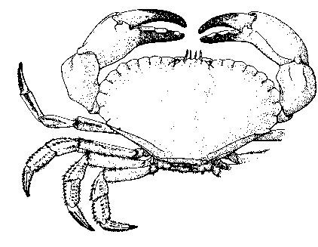

Carapace width

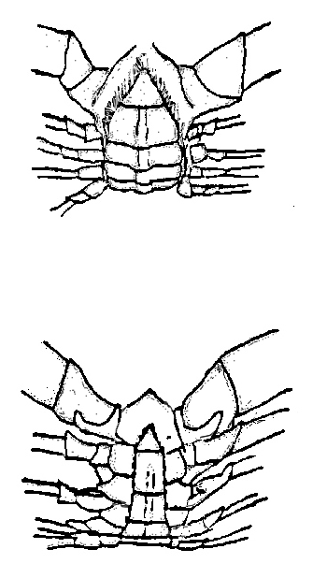

Female

Male

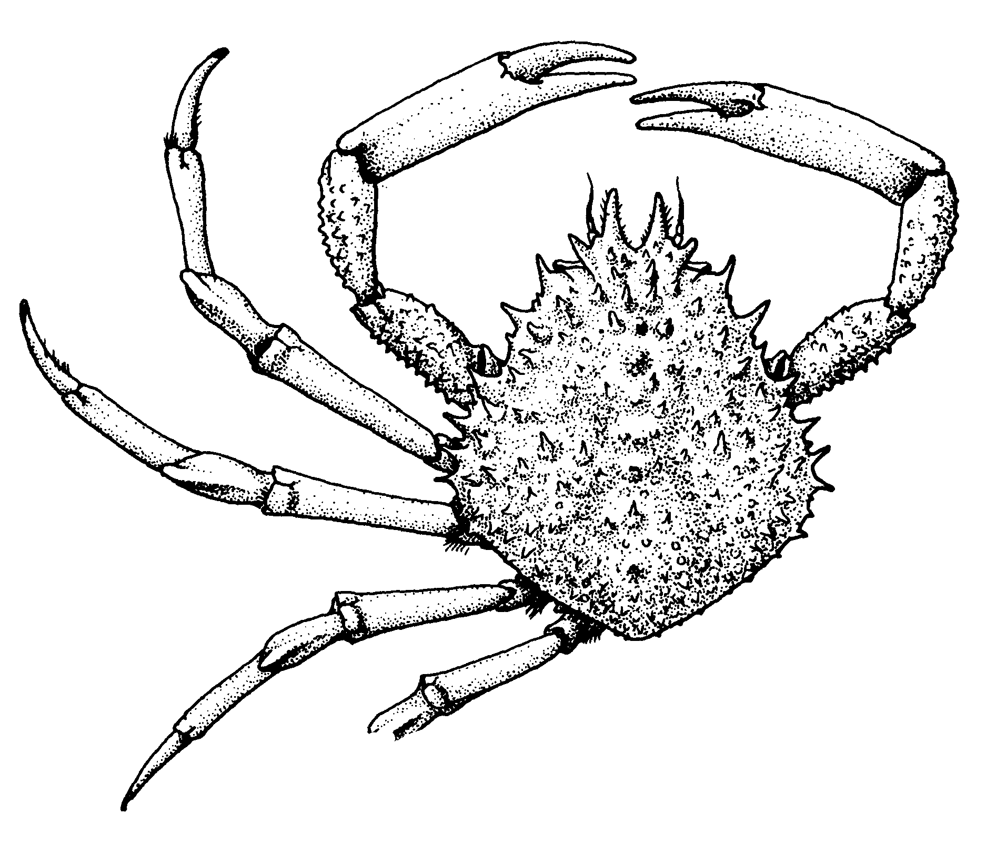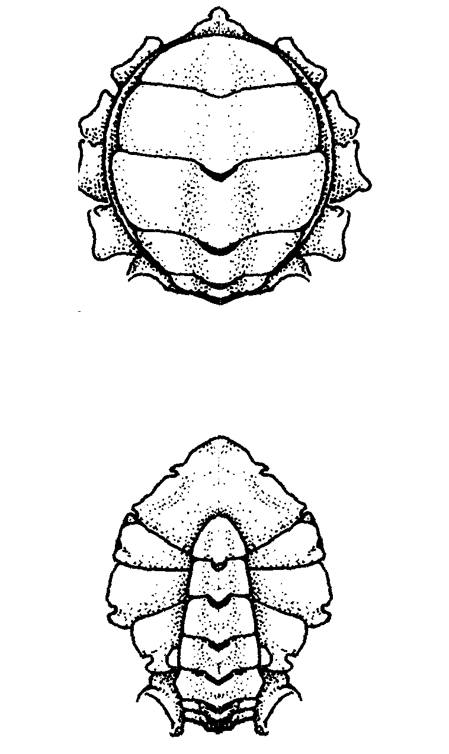

Female

Male

Carapace length

Figure 3.2. Measurement and sexing of *Cancer pagurus.* Size to be measured to the lower mm.

Figure 3.3. Measurement and sexing of *Maia squinado.* Size to be measured to the lower mm.

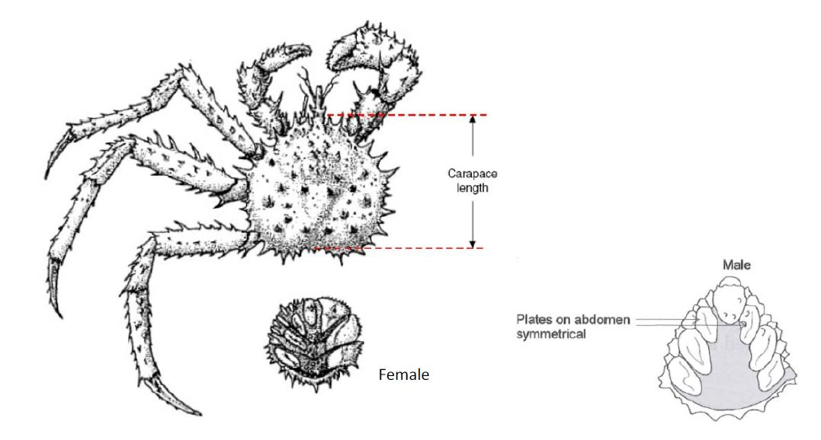

Figure 3.4. Measurement and sexing of *Lithodes maja*. Size to be measured to the lower mm.

Figure 3.5. Measurement and sexing of *Nephrops norvegicus* and *Homarus gammarus* Size to be measured to the lower mm.

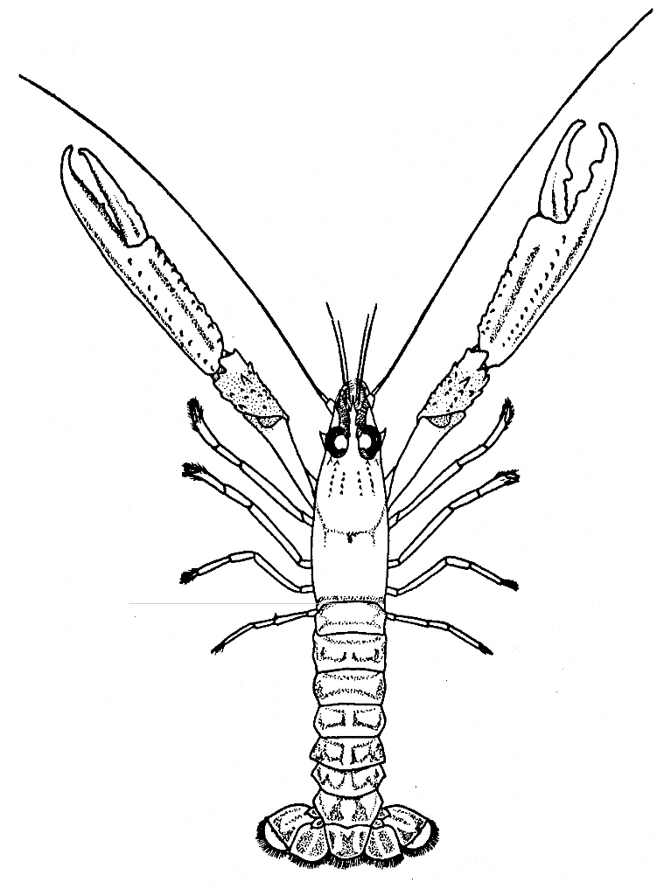

Carapace length

Centre line

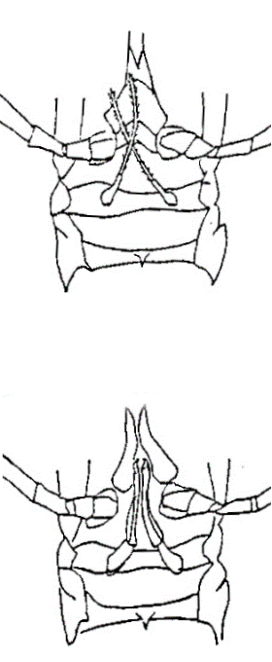

Female

Male

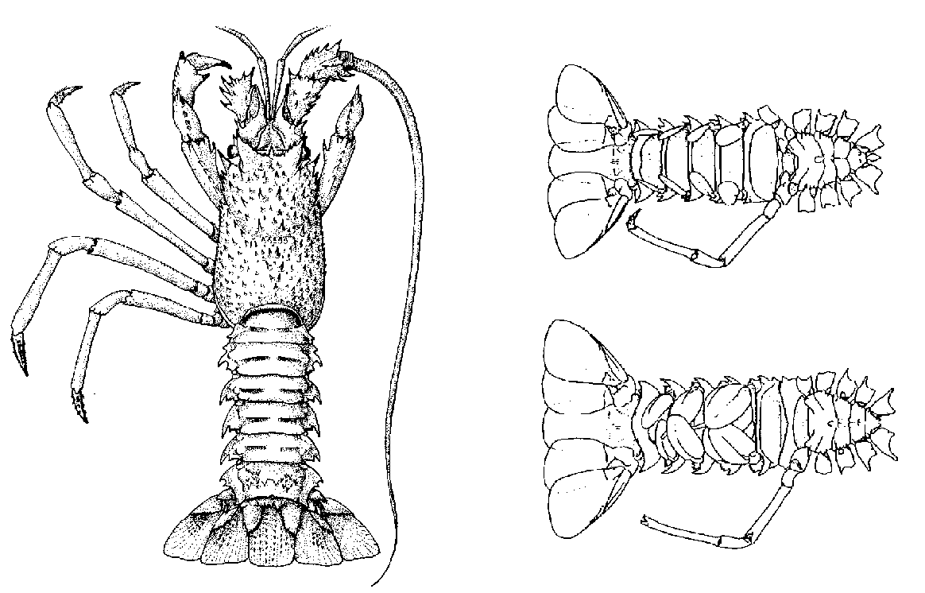

Male

Female

Carapace length

Figure 3.6. Measurement and sexing of *Palinurus* spp Size to be measured to the lower mm.

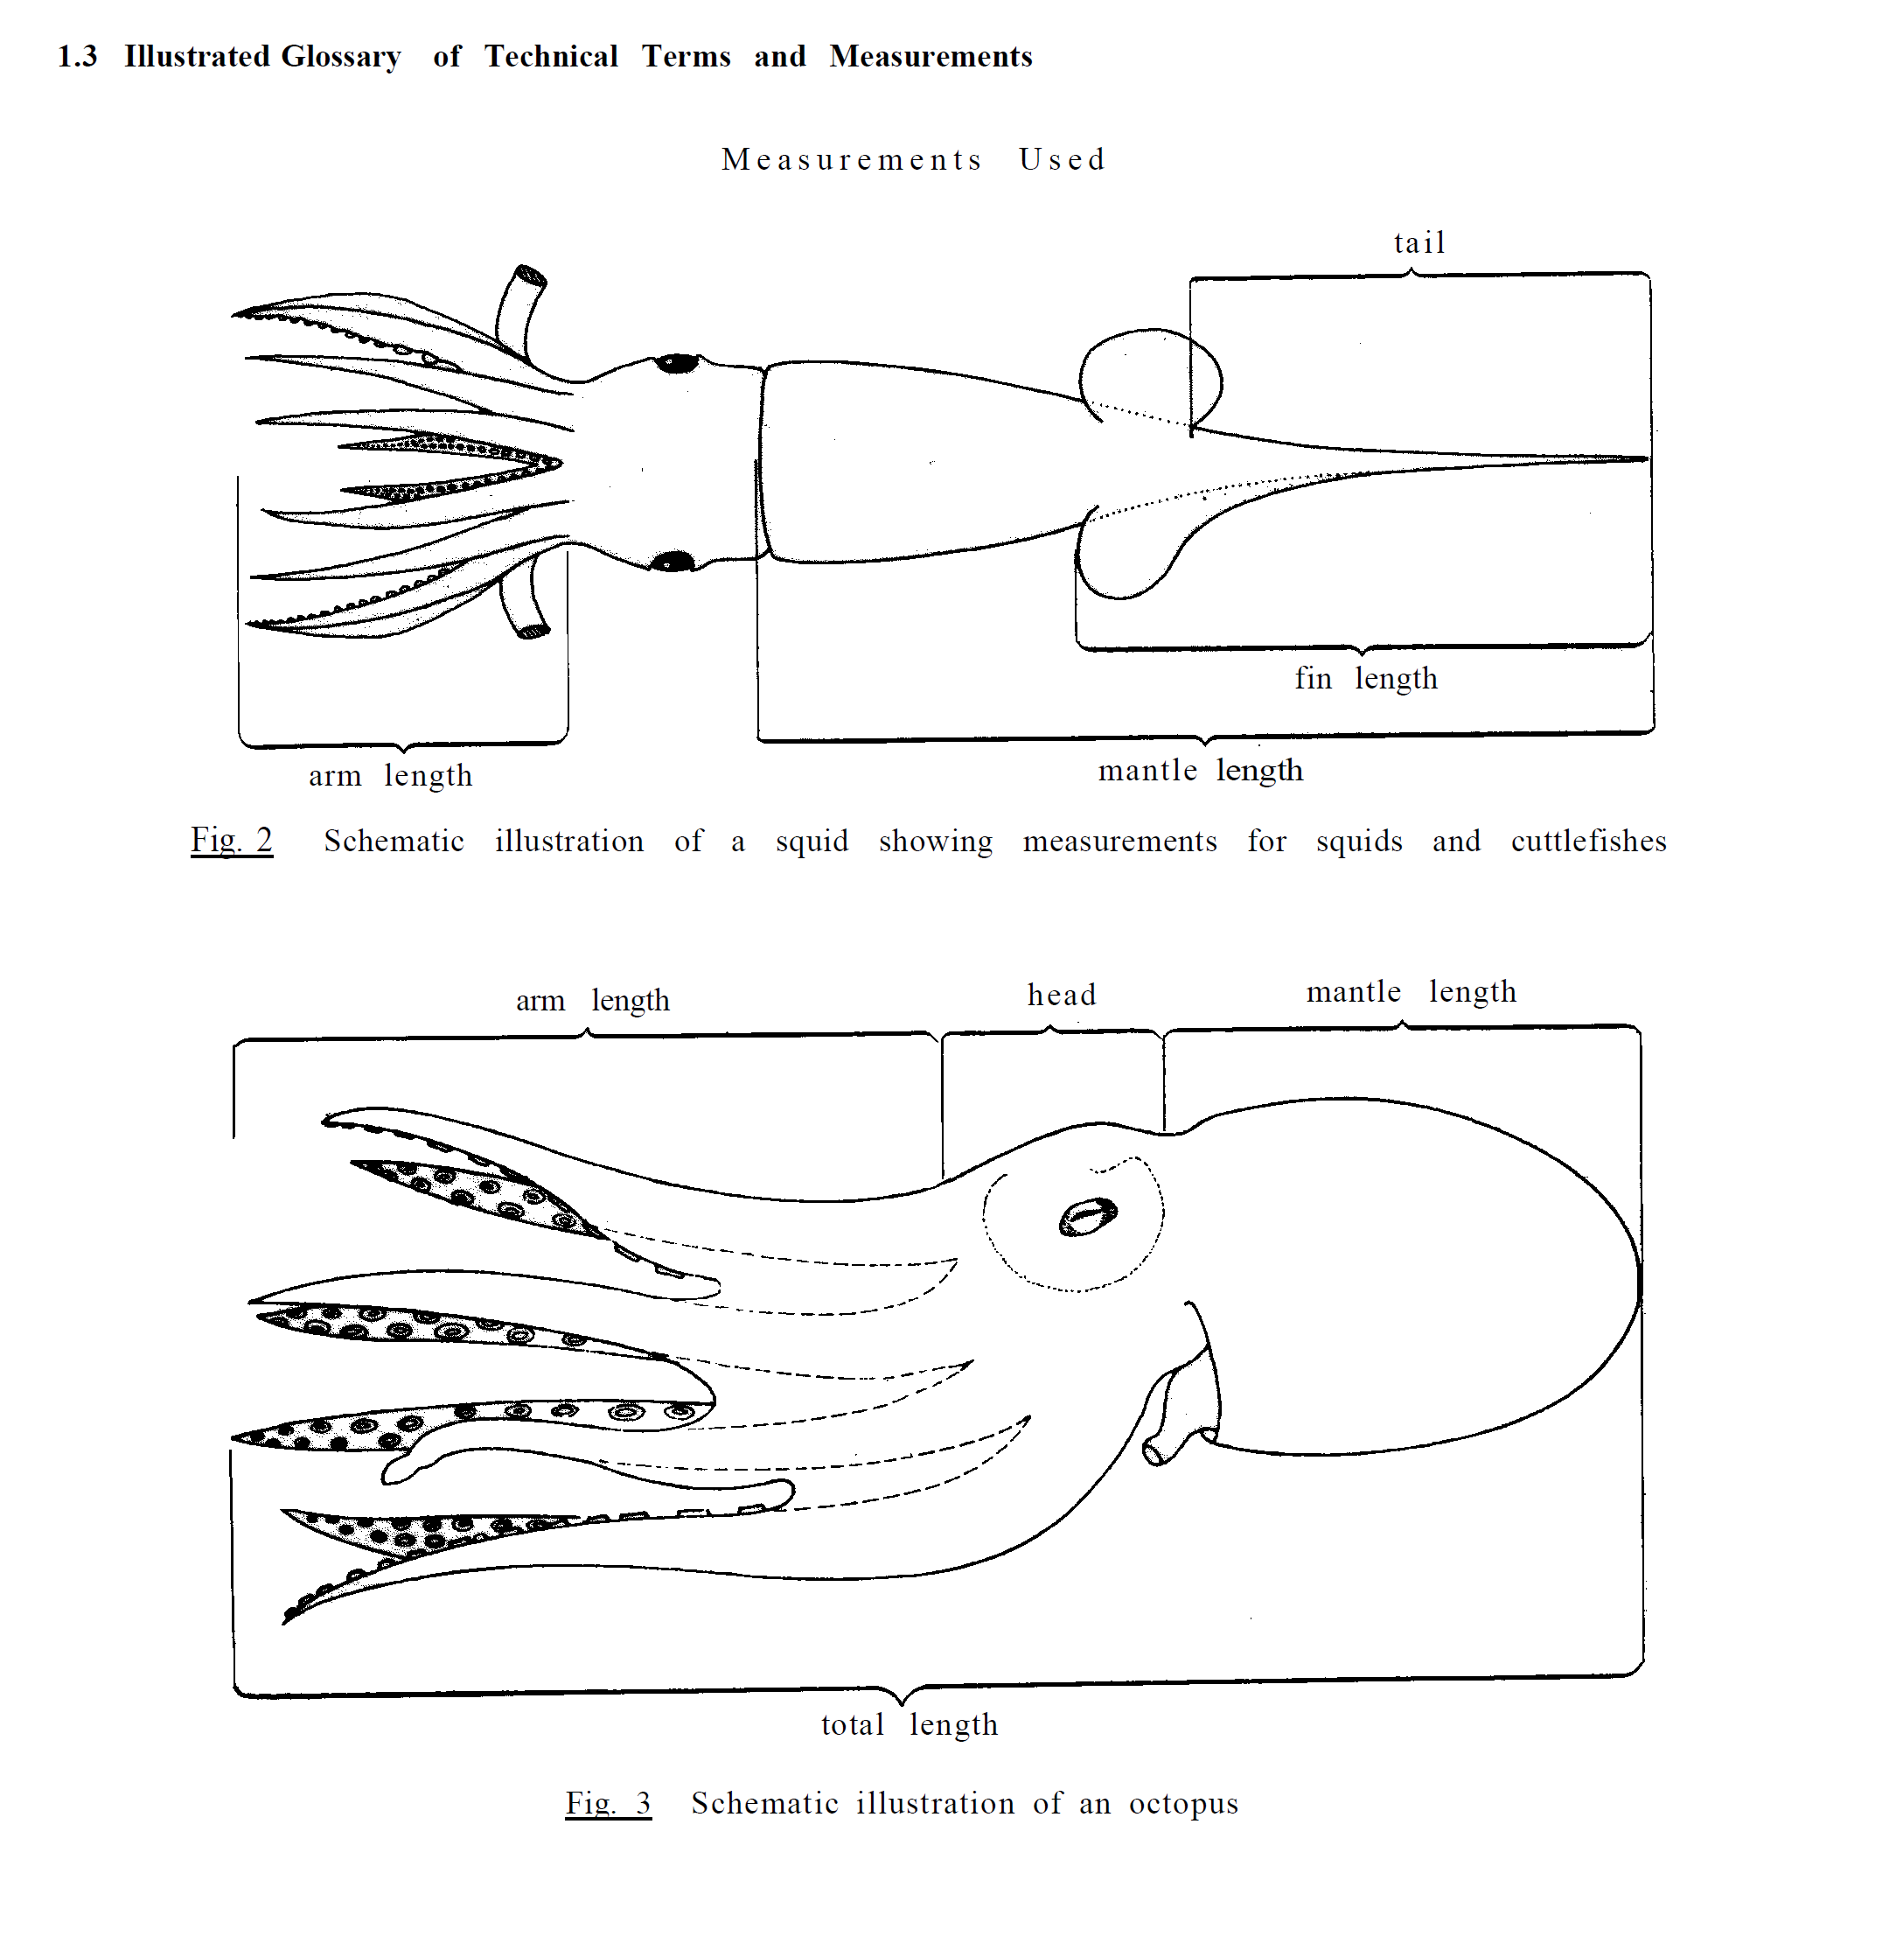

Figure 3.7. Measurement of Cephalopods; mantle length to be measured to lower cm.

## Measurement types for deep-water species



The majority of species encountered during the deep-water surveys are measured to the centimetre below using total length **(TL;** see diagram directly above). There are, however, some exceptions. As a result of the great variety of body shapes of deep-water fish species and the fragility of their tails and fins, some species are not measured to total length. Listed below are the respective taxa, with details of the length measurements to be collected for each. Historically, these species, if caught, may not have been measured to this protocol and care should be taken if using data for these species.

### Smoothheads and Searsids (*Alepocephalidae* and *Searsidae*)

Standard length (**SL**) measurement taken from the tip of snout/anterior point of head to the end of the fleshy caudal peduncle. Not to be confused with TL which includes the caudal fin rays. All smoothheads and searsids are measured to the nearest whole cm below.



### Grenadiers (*Macrouridae*)

Measurement taken from the tip of the snout to the first anal fin ray (Pre Anal Fin Length, **PAFL**; see diagram below). All grenadiers are measured to the nearest 0.5 cm below.



### Chimaeridae (Rabbitfish)

All **Rabbitfish** except Rhinochimaeridae are measured to pre-supra caudal fin length (**PSCFL**), which is from the tip of the snout to the point just before the start of the supra caudal fin (see diagram below). All Chimaerida are measured to the nearest cm below.



## Collection of marine litter from trawl

Marine litter is one of the MSFD descriptors. With this in mind, from 2011, all North Sea IBTS surveys collect data on marine litter captured in the GOV trawl. There are currently two formats for submitting litter data, the original CEFAS trawl litter categories used by IBTS previously (C-TS) or the revised CEFAS trawl litter survey parameters (C-TS-rev); both are described in Annex 14.

Both the C-TS or C-TS-rev format classification systems are composed of main categories of litter, each further divided into sub-categories. Items that are fragments from one item are to be counted as one item. All items that fall within a single category are to be counted and weighed individually; they should not be grouped. Photos of litter in each trawl sample are optional, not mandatory.

Once collected these data are to be be sent to each institutes marine litter co-coordinator and uploaded to ICES via <https://datras.ices.dk/Data%20submission/Default.aspx>. The litter data collection procedures are currently in revision, therefore, national survey coordinators must ensure they are up to date with the current procedures (see ICES website) prior to the survey.

# MIK net

## Q1 sampling

The MIK net is midwater ring net and is the standard gear for the sampling of fish larvae during the International Bottom Trawl Survey in the first quarter.

A separate manual on all procedures and protocols regarding the MIK sampling on quarter 1 IBTS surveys has been developed (SISP 2). This is available on the ICES webpage. All nations sampling during IBTS Q1 must follow the protocols outlined in the MIK documentation.

# Environmental data

Either before or after each GOV trawl, the following minimum hydro­graphical data are to be collected:

* surface temperature
* bottom temperature
* surface salinity
* bottom salinity

When using a CTD-probe for measuring temperature and salinity, an appropriate calibration should be undertaken.

Details of environmental data should be submitted to the ICES Data Centre according to established procedures. The national hydrographic station number must be reported in Record Type 1 to allow the link to be made between haul data and environmental data.

The following additional environmental data should be collected if available:

* surface current direction
* surface current speed
* bottom current direction
* bottom current speed
* wind direction
* wind speed
* swell direction
* swell height

The above parameters, if collected, are reported in the ‘Haul Information file HH’ (Annex 15). Each nation must ensure that the units are uploaded as required in the HH specifications.

# Exchange specifications for IBTS data

Four distinct types of computer records have been defined for standard storage of the IBTS data:

Type 1: HH – Record with detailed haul information (Annex 15)

Type 2: HL – Length frequency data (Annex 16)

Type 3: CA – Sex-maturity-age–length keys (SMALK; Annex 17)

Type 4: LT – litter reporting format (Annex 18).

The summaries of the formats of these record types are given in the appendices and detailed descriptions can also be found at the ICES web page: <https://datras.ices.dk/Data_products/ReportingFormat.aspx>.

Provisional data obtained from the North Sea and Skagerrak/Kattegat should be submitted to the quarterly coordinator as soon as possible after completion of the cruise (see DATRAS website for upload deadlines). Annex 19 lists the sampling areas and standard areas for the calculation of abundance indices (using CM 1977/Gen:3 Figures 6.1 and 6.2 for guidance), while CM 1977/Gen:3 Figure 6.3 shows the index areas for those stocks that use the delta-GAM index estimation approach. Annex 20 lists the length splits for the various target species.

Final data should only be submitted to the ICES Data Centre after the national institute has checked the data; data is further checked using official checking programs issued by ICES within DATRAS, but institutes **must** instigate their own data checking routines and not rely solely on those within DATRAS.

# References

Heessen, H., Dalskov, J., Cook, R. M. 1997. The International Bottom Trawl survey in the North Sea, the Skagerrak and Kattegat. ICES, Copenhagen (Denmark). ICES CM 1997/Y:31, 25 pp.

ICES. 1963. International Young Herring Surveys. Report of Working Group meeting in Ĳmuiden, 26–27 March, 1963. ICES CM 1963/Herring Cttee: 101.

ICES. 1974. Report of the Working Group on North Sea Young Herring Surveys. ICES CM 1974/H:6.

ICES. 1977. Report of the Working Group on North Sea Young Herring Surveys. ICES CM 1977/H:11.

ICES. 1981a. Manual for the International Young Fish Surveys in the North Sea, Skagerrak and Kattegat. ICES CM 1981/H:9.

ICES. 1981b. Report of the Joint meeting of the International Young Herring Survey. Working Group and the International Gadoid Survey Working Group. Ĳmuiden, 12–14 May, 1981. ICES CM 1981/H:10.

ICES. 1986. Manual of the International Young Fish Survey in the North Sea, Skagerrak and Kattegat, 3rd revision. ICES CM 1986/H:2.

ICES. 1990. Report of the International North Sea, Skagerrak, and Kattegat Bottom Trawl Survey Working Group. ICES CM 1990/H:3.

ICES. 1992. Report of the International Bottom Trawl Survey Working Group. ICES CM 1992/H:3. 21 pp.

ICES. 1996. Report of the International Bottom Trawl Survey Working Group. ICES CM 1996/H:1.

ICES. 1999. Manual for the International Bottom Trawl Surveys. Revision VI. ICES CM 1999/D:2, Appendum 2, Ref. G. 51 pp.

ICES. 2002. Report of the International Bottom Trawl Survey Working Group. ICES CM 2002/D:03.

ICES. 2006. Manual for the International Bottom Trawl Surveys. Revision VII, ICES CM 2006/RMC:03.

ICES. 2008. Report of the International Bottom Trawl Survey Working Group (IBTSWG), 31 March ‐ 4 April 2008, Vigo, Spain. ICES CM 2008 RMC:02. 228 pp.

ICES. 2009. Report of the Study Group on Survey Trawl Standardisation (SGSTS), by correspondence. ICES CM 2009/FTC:09. 127 pp.

ICES. 2012a. Report of the International Bottom Trawl Survey Working Group (IBTSWG), 27-30 March 2010, Lorient, France. ICES CM 2012/SSGESST :03. 323 pp.

ICES. 2012b. Report of the Workshop on Sexual Maturity Staging of sole, plaice, dab and flounder, ICES CM 2012/ACOM:50.

ICES. 2012c. Manual for the International Bottom Trawl Surveys. Series of ICES Survey Protocols. SISP 1-IBTS VIII. 68 pp.

ICES. 2012d. Manual for the Midwater Ring Net sampling during IBTS Q1. Revision 1. 16 p.

ICES. 2013a. Report of the workshop on implementation in DATRAS of confidence limits estimation of abundance indices from bottom trawl survey data. 10-12 May 2006, ICES Headquarters, Copenhagen. 39 pp.

ICES. 2013b. Manual for the International Bottom Trawl Surveys. Series of ICES Survey Protocols. SISP 3-IBTS IX. 68 pp.

ICES. 2013c. Manual for the Midwater Ring Net sampling during IBTS Q1. Series of ICES Survey Protocols. SISP 2-MIK 2. 18 pp.

ICES. 2015a. Report of the International Bottom Trawl Survey Working Group (IBTSWG), 23-27 March 2015, Bergen, Norway. ICES CM 2015/SSGIEOM:24. 278 pp.

ICES. 2015b. Report of the Benchmark Workshop on North Sea Stocks (WKNSEA), 2–6 February 2015, Copenhagen, Denmark. ICES CM 2015/ACOM:32. 253 pp.

ICES. 2016. First Interim Report of the International Bottom Trawl Survey Working Group (IBTSWG), 4-8 April 2016, Sète, France. ICES CM 2016/SSGIEOM:24. 292 pp.

ICES. 2017a. Interim Report of the International Bottom Trawl Survey Working Group. IBTSWG Report 2017 27-31 March 2017. ICES CM 2017/SSGIEOM:01. 337 pp.

ICES: 2017b. Report of the Benchmark Workshop on North Sea Stocks (WKNSEA), 6–10 February 2017, Copenhagen, Denmark. ICES CM 2017/ACOM:34. 673 pp.